Trigonometry Quiz
Q1) Find the length of the third side:
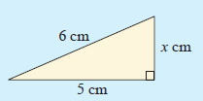

Q2) Find the unknown length:
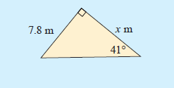

Q3) Find the measure of the angle marked θ in:
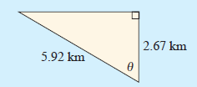

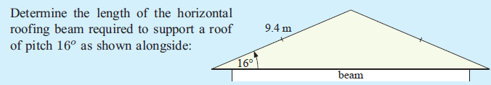
Q4)

Q5) Find the length of side [BC], correct to 2 decimal places:
